**Create a build using Git and maven:**

1. Push a maven project into git repository:

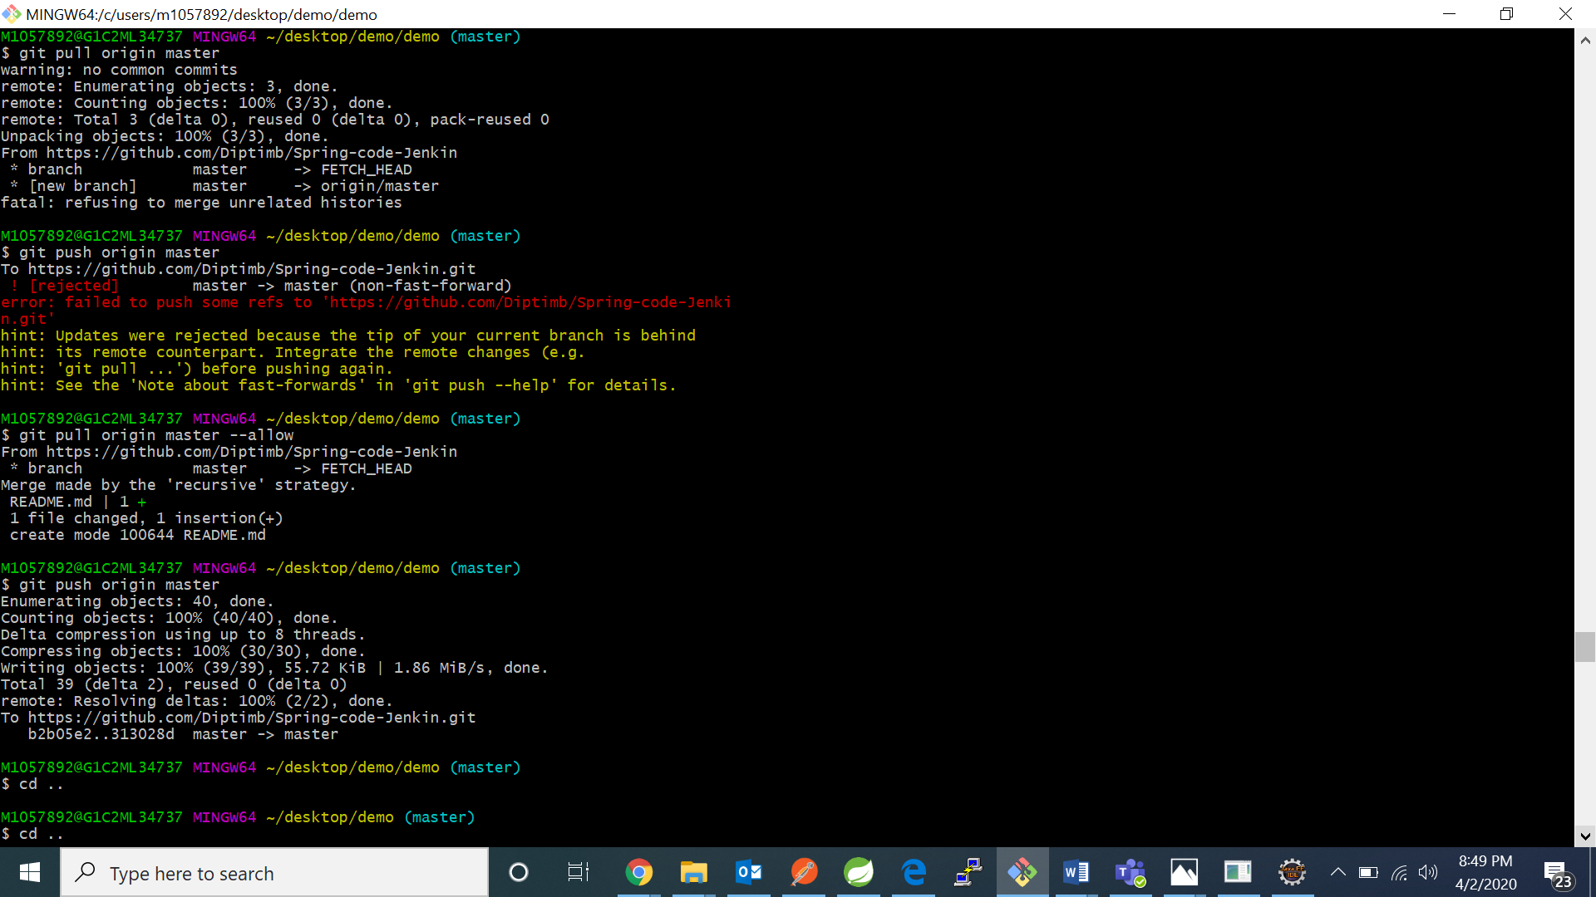

1. Now open the jenkins portal and click on new item

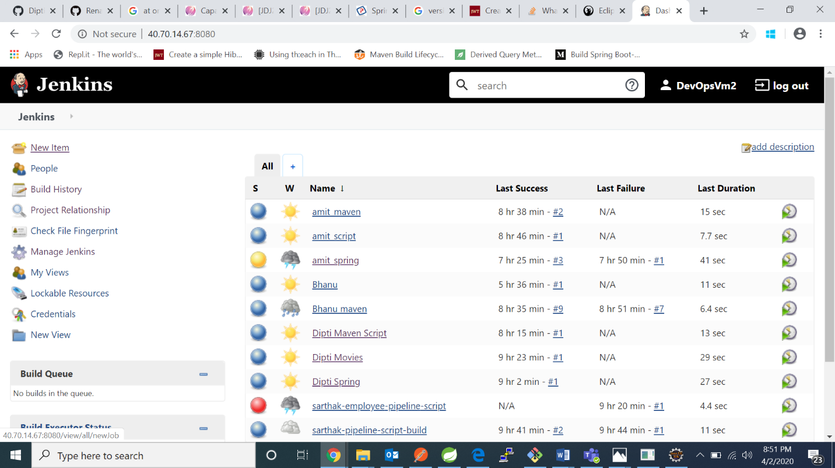

1. Now enter a project name and click on maven project and click on ok:

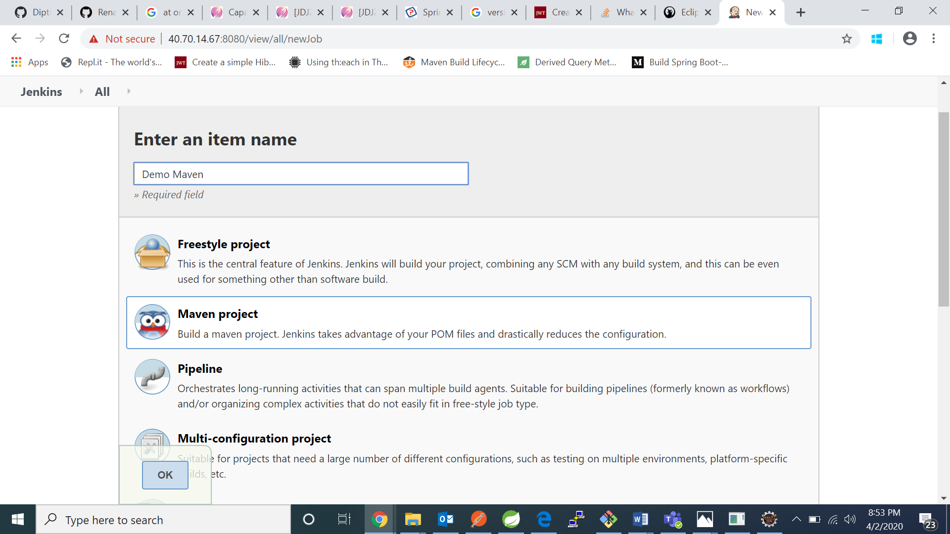

1. In general click on GitHub checkbox and paste your GitHub repository url: 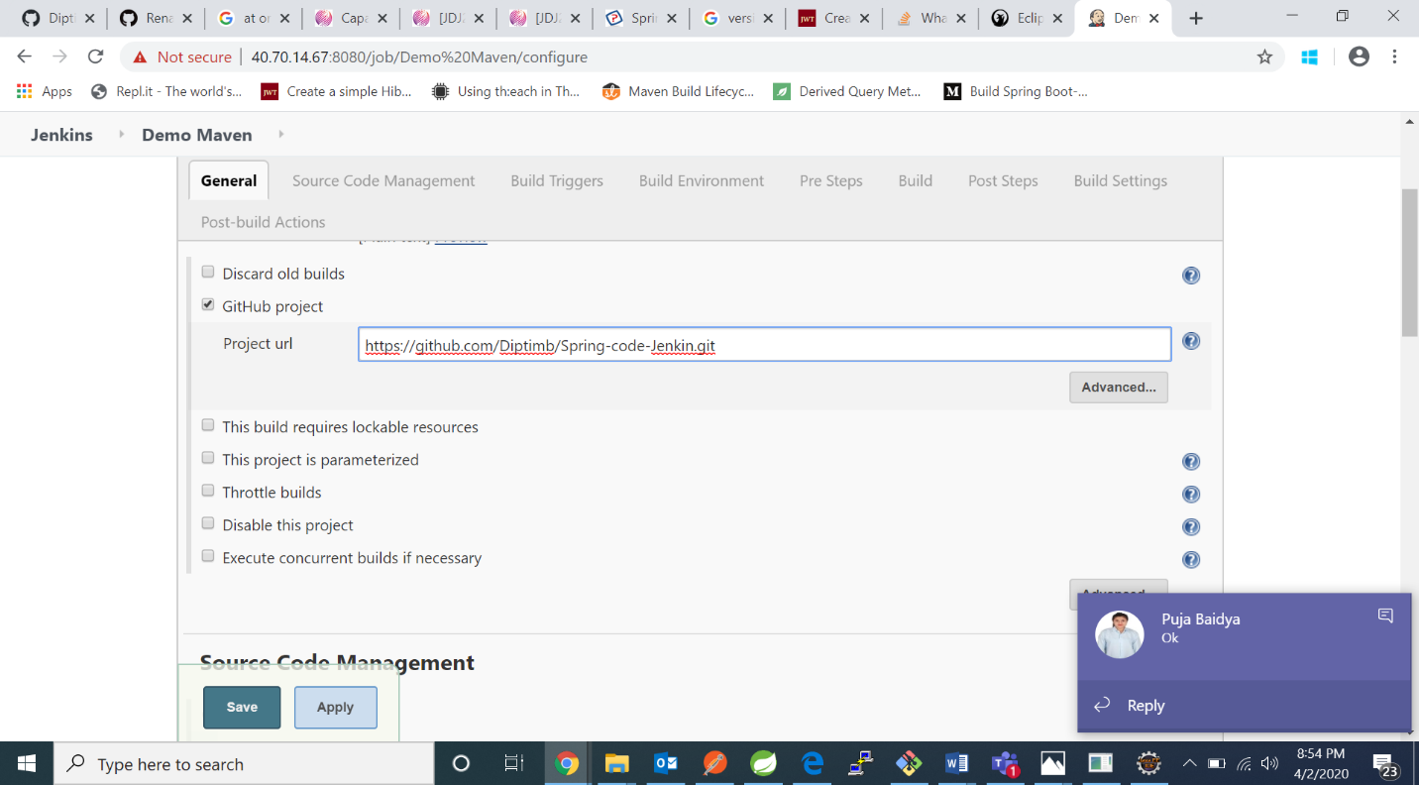
2. Under source code management click Git and paste your GitHub url:

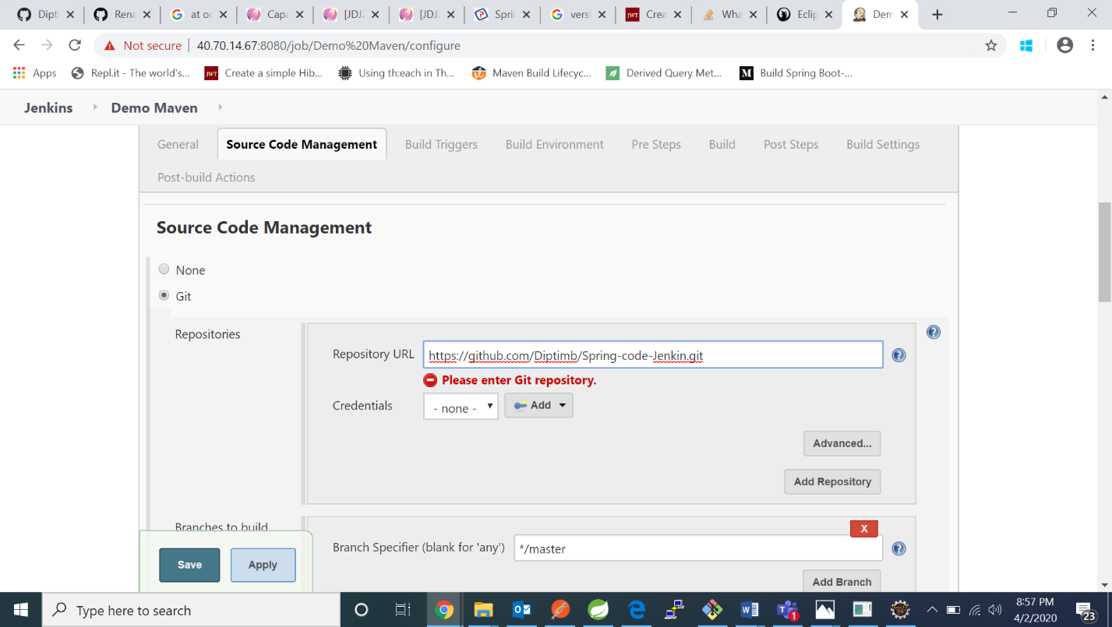

1. Under Pre Steps choose –invoke top level maven targets and in goals write clean package

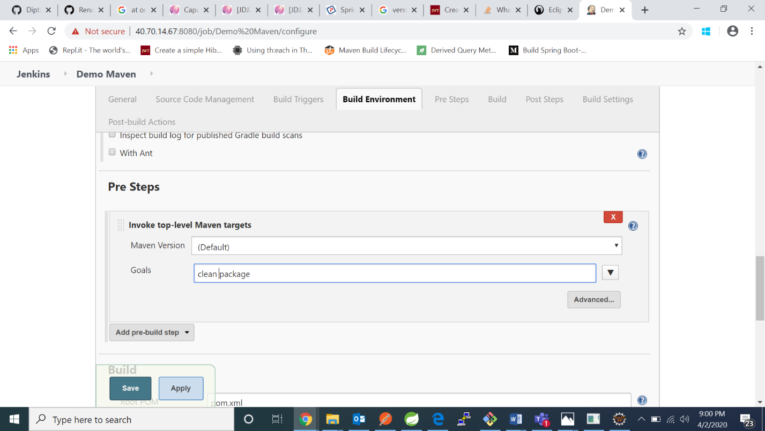

1. In build section , in goals and options write clean and package and click on save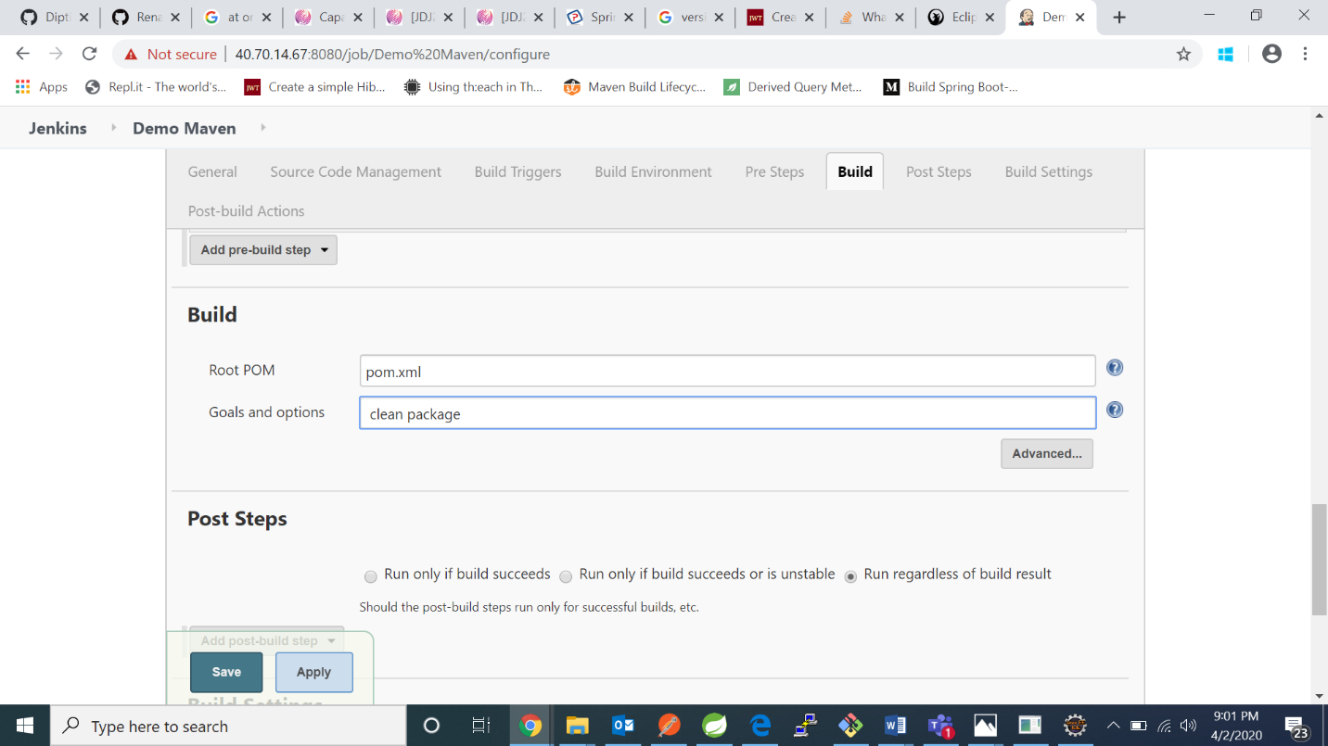
2. Maven project is created

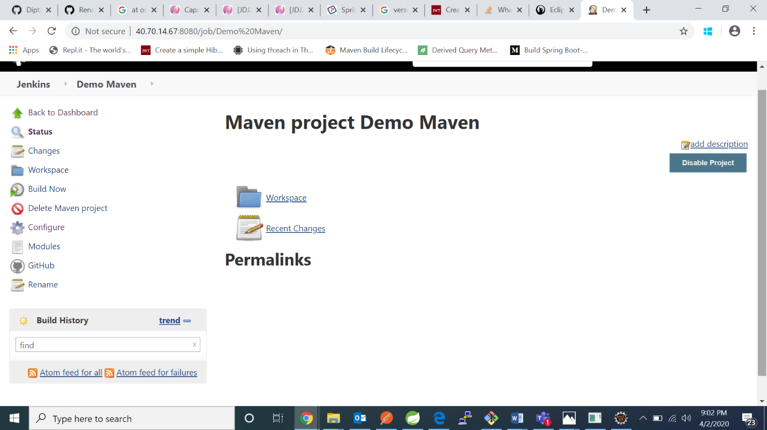

1. Now click on build now: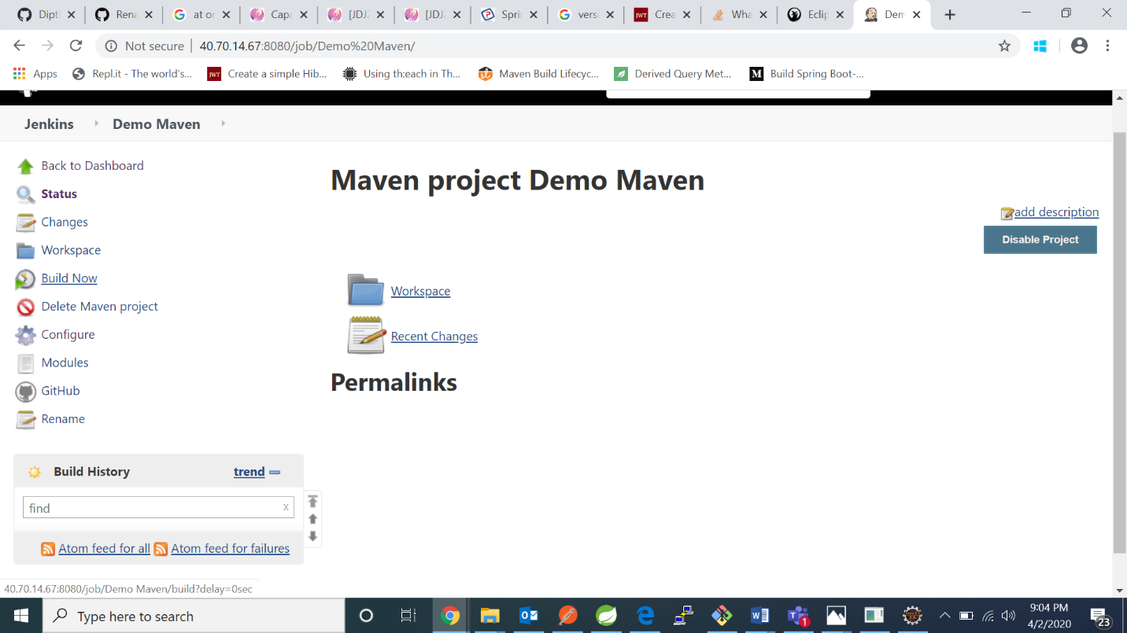
2. We can see the project is building in below:

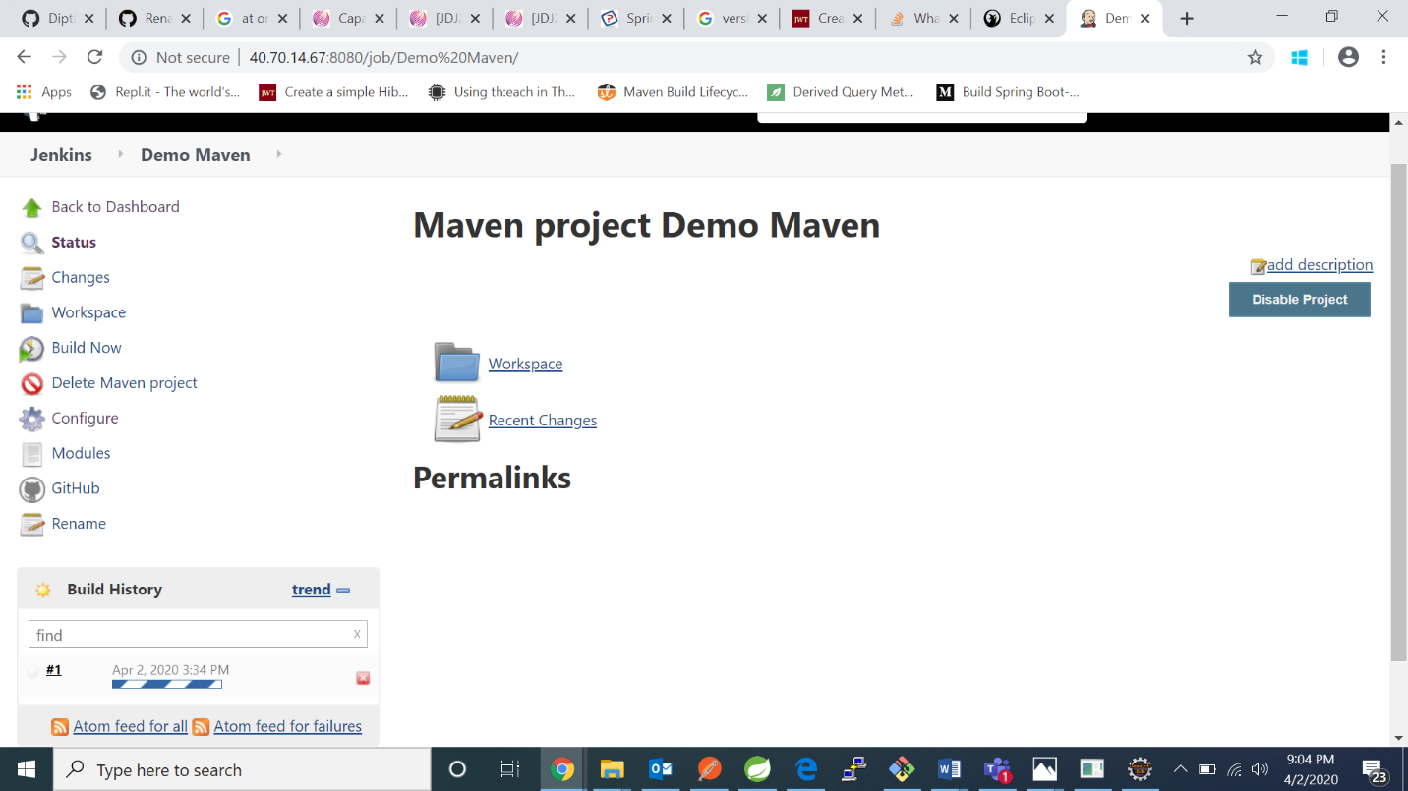

1. Initially I got this result:

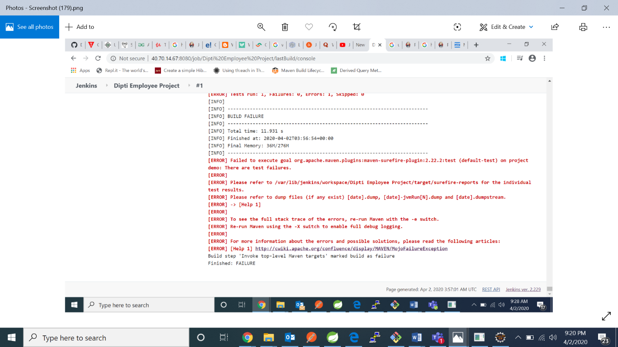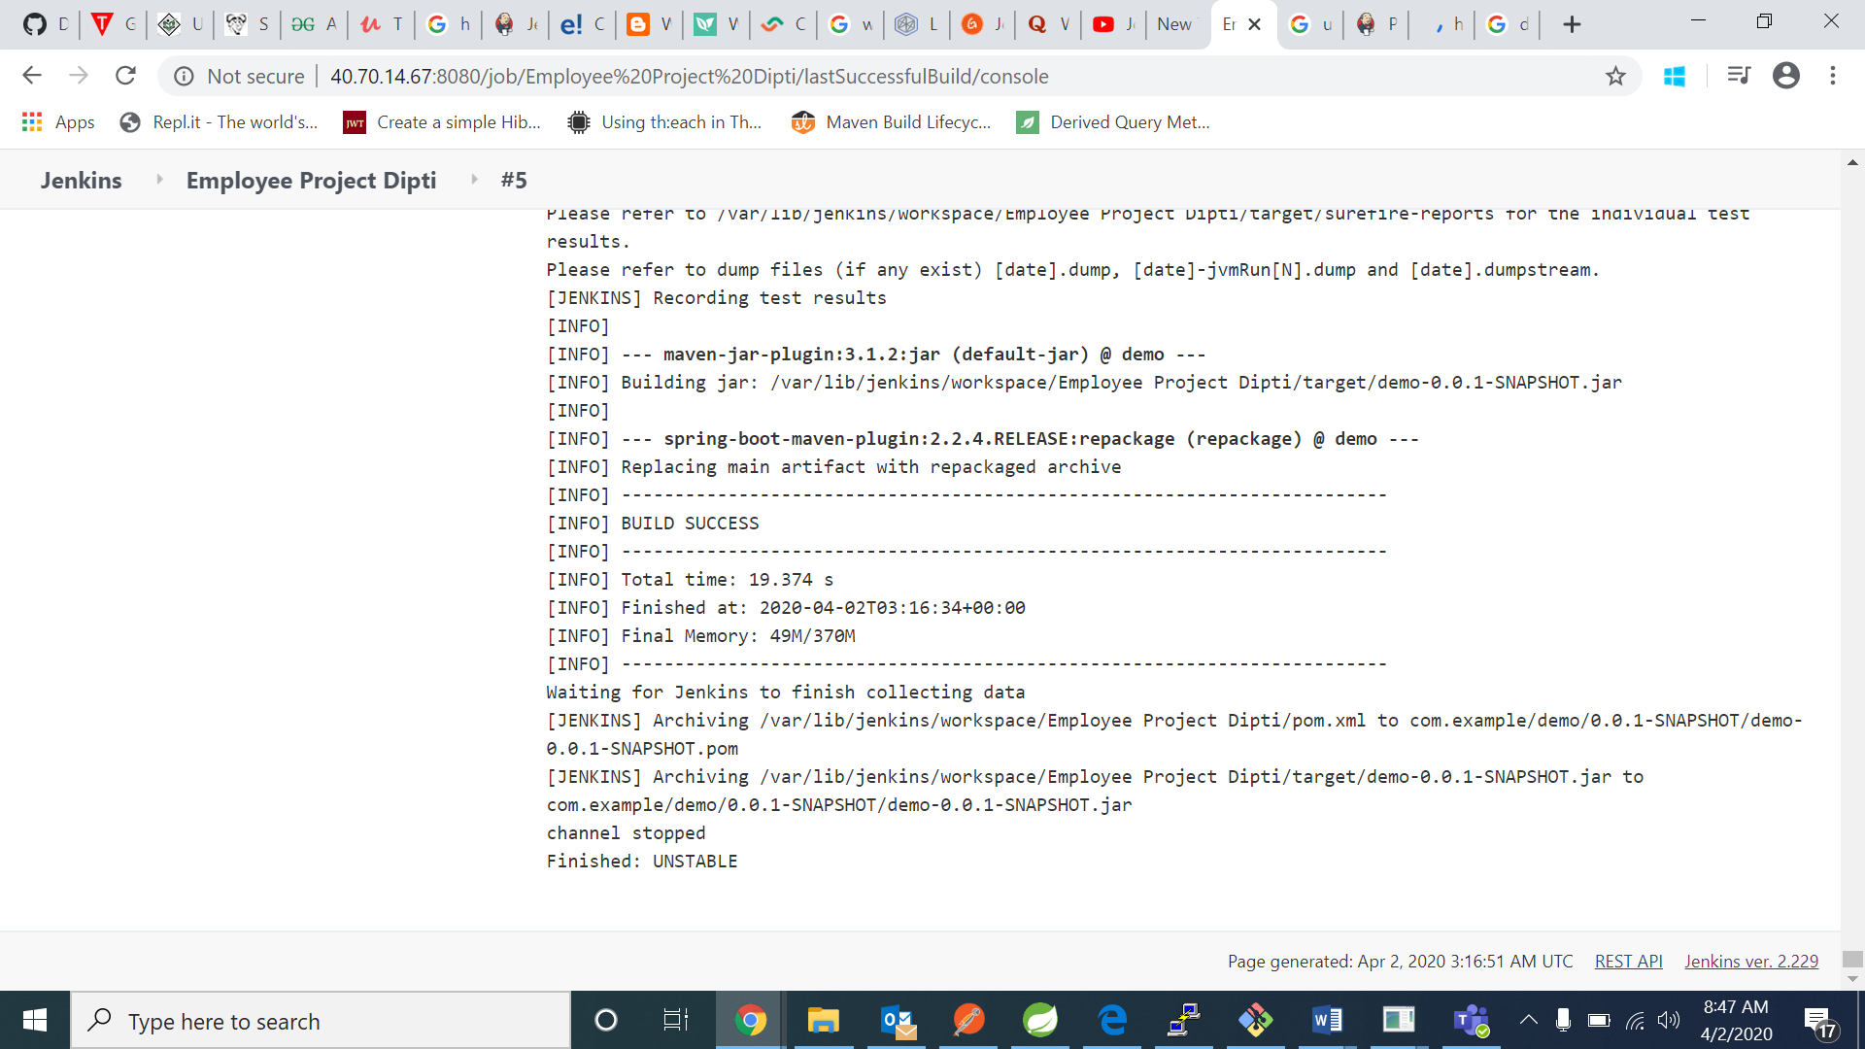

To resolve this go to manage Jenkins

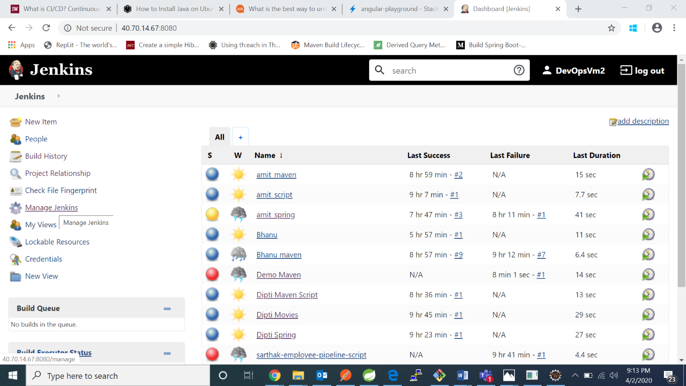

Go to manage plugins:

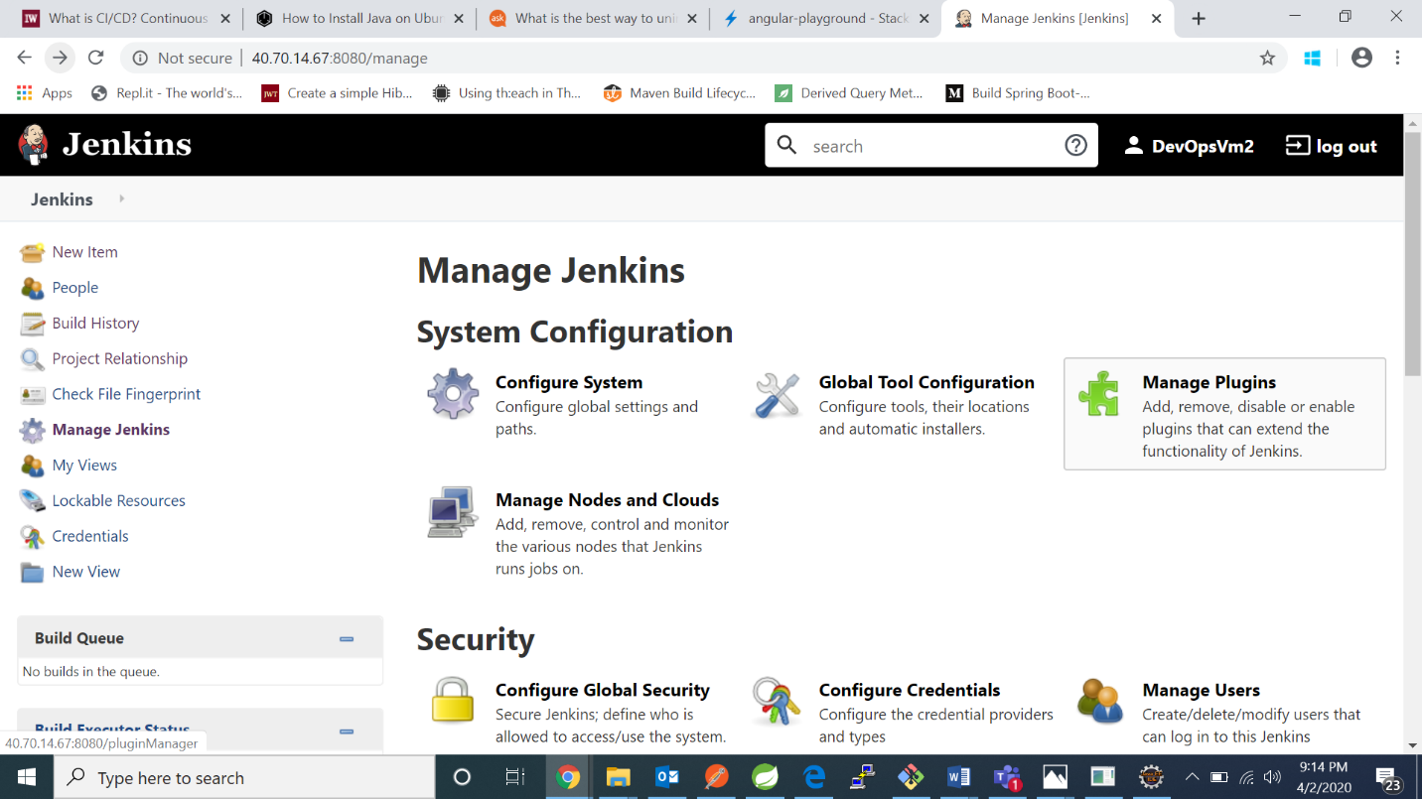

Go to available tab and in search bar type “maven “

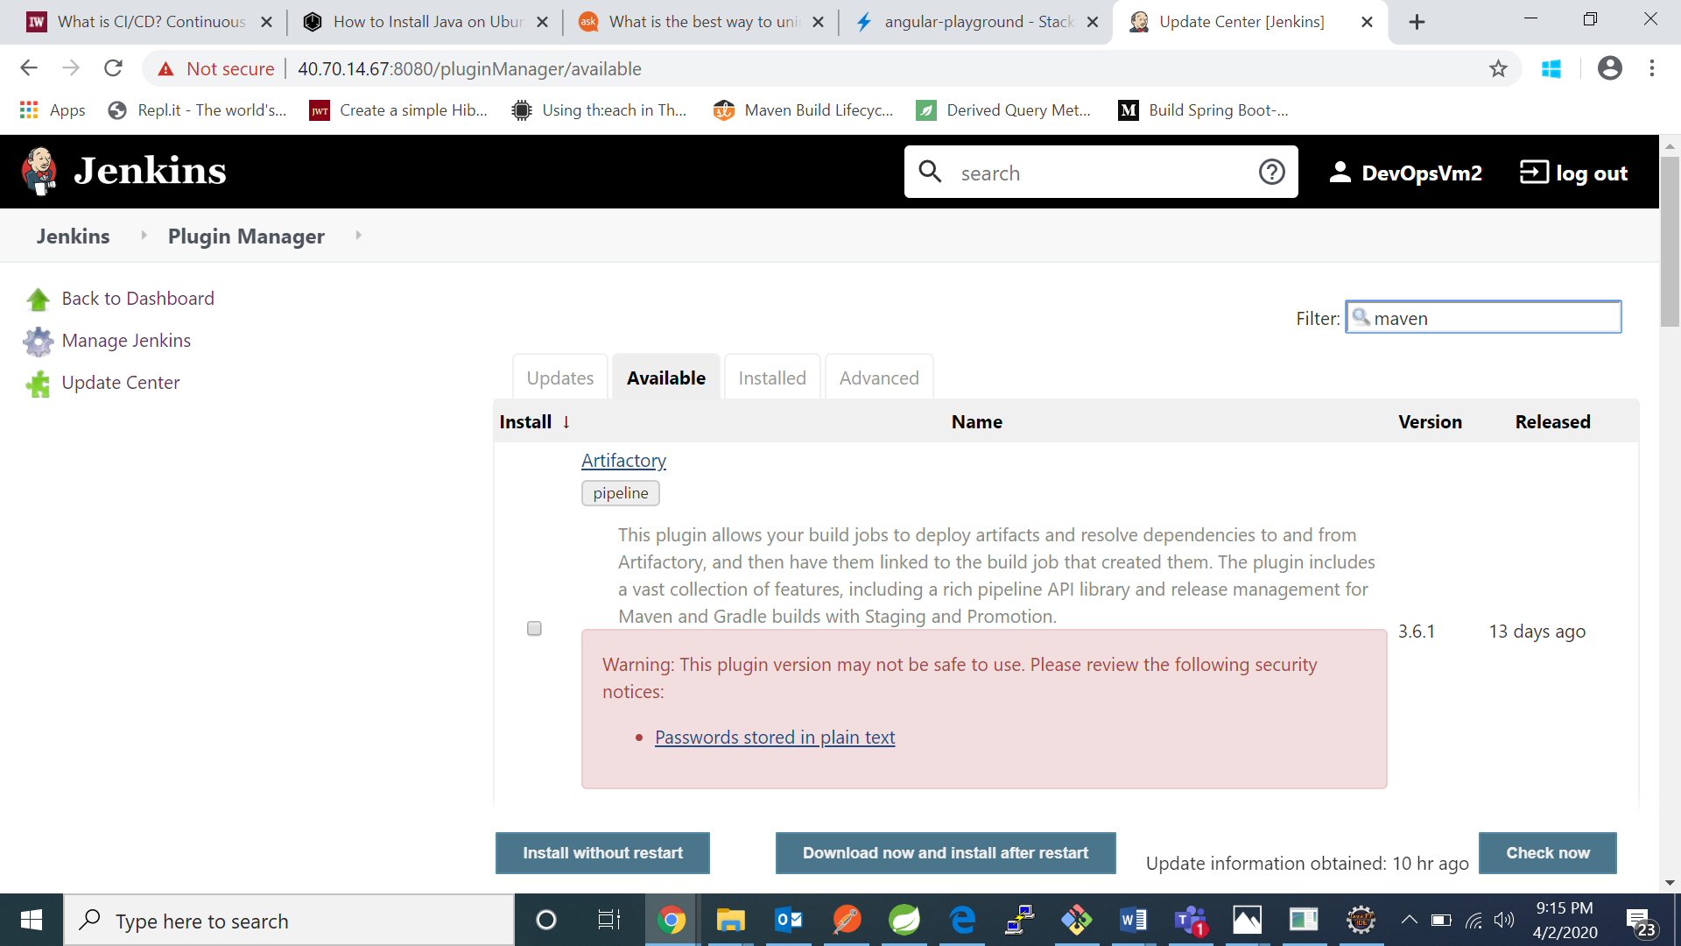

Click on maven integration plugin and maven metadata plugin for Jenkin CI and click on install without restarting

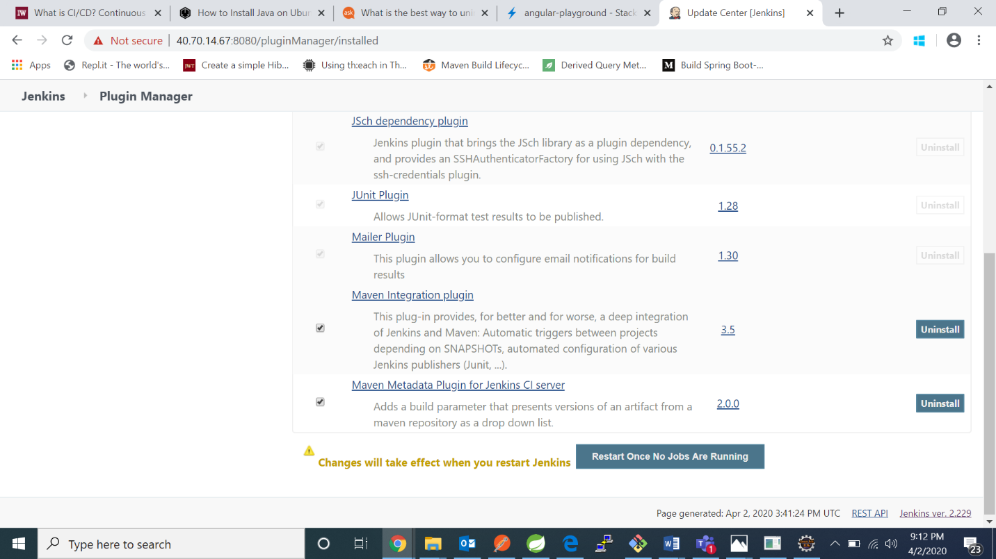 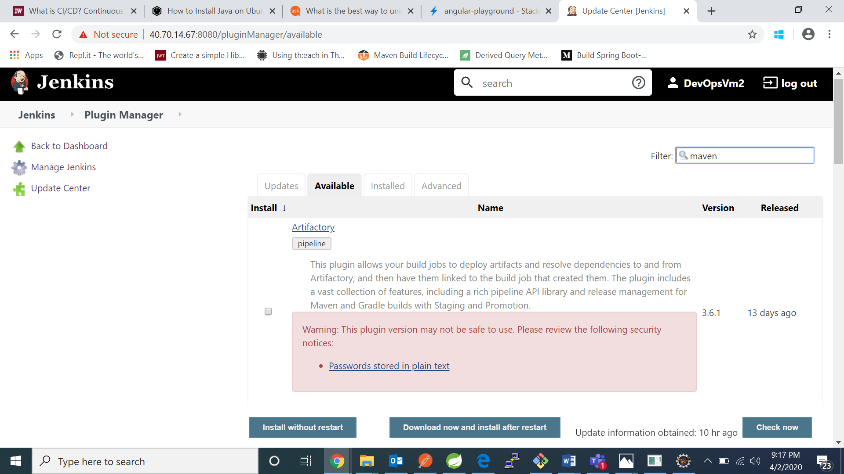

1. After installing the plugins go back to jenkins dashboard and click on build

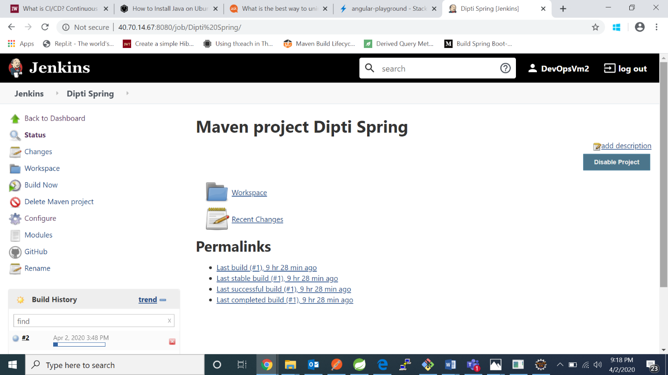

1. I got this result : 